INTRODUCTION:

OVERVIEW:

**TechPro Solutions, an IT services company**, utilizes Zoho Books to efficiently manage their client billing and invoicing. They track project expenses, record billable hours, and generate professional invoices using Zoho Books. The software helps them streamline their financial processes and provides insights into their profitability. TechPro Solutions is a Private Limited company also registered under GST in Tamil Nadu. TechPro Solutions offers various expert IT consulting services in India and outside India.

PURPOSE:

While using Zoho Book, we learnt about cloud based Accounting system. It can be access at Anytime at Anywhere at we needed. We can directly link bank account in our Zoho book.

The Main Purpose of the Zoho book is a Single secure location to keep up with your company’s bills and invoices, reconcile your Bank statements, control your spending, oversee projects, and eliminate GST compliance worries.

PROBLEM DEFINITION AND DESIGN THINKING:

EMPATHY MAP:

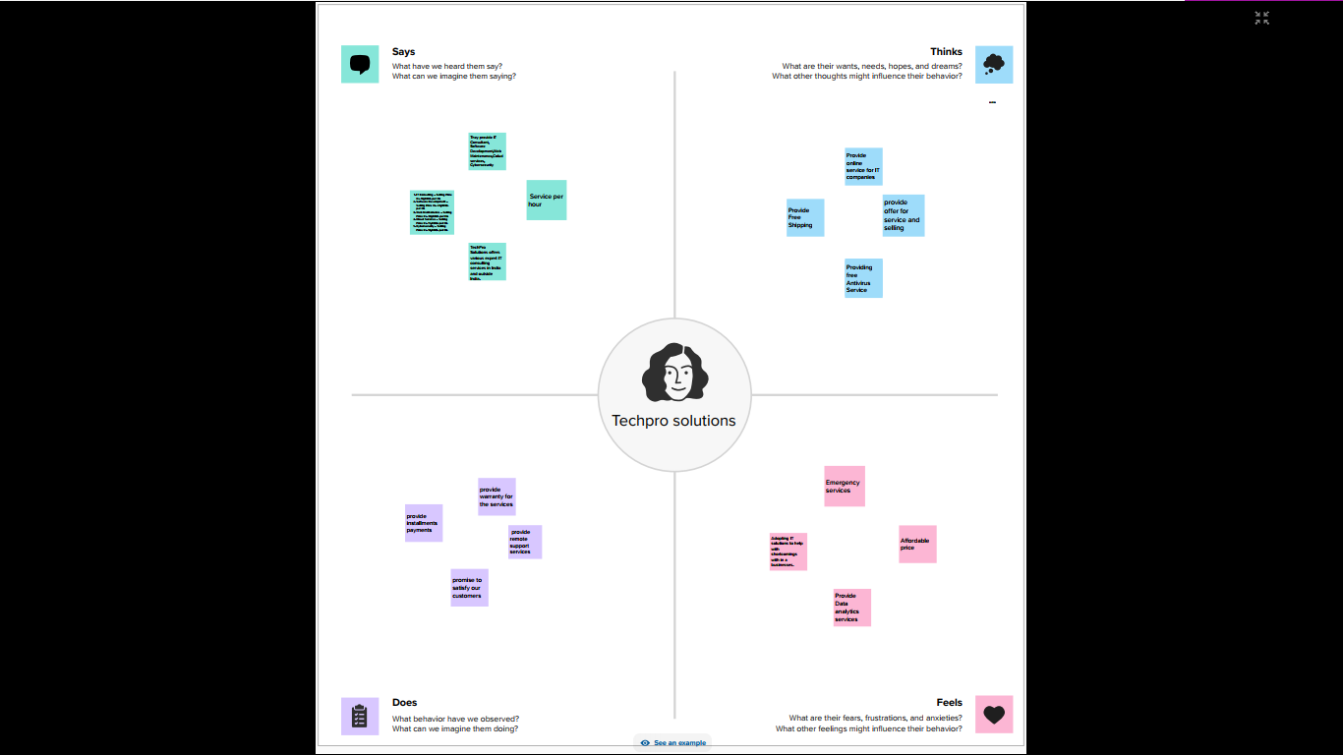

IDEATION AND BRAINSTROMING:

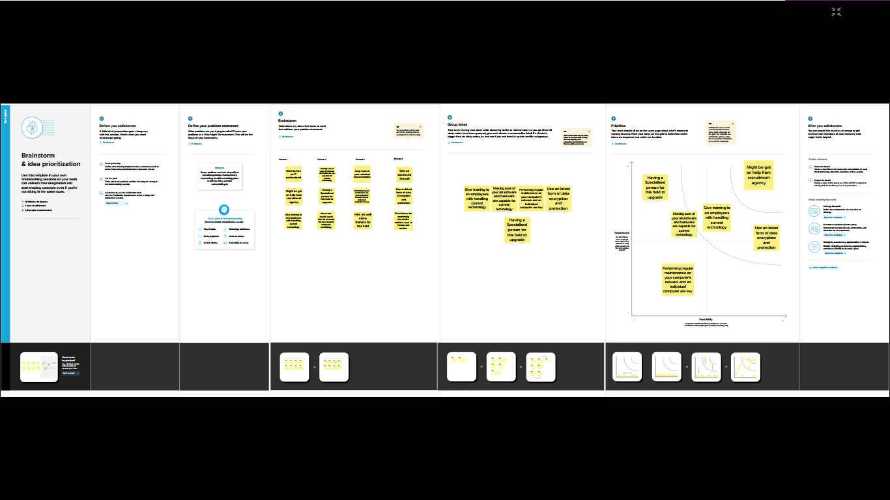

RESULT:

BALANCE SHEET(OUTPUT):

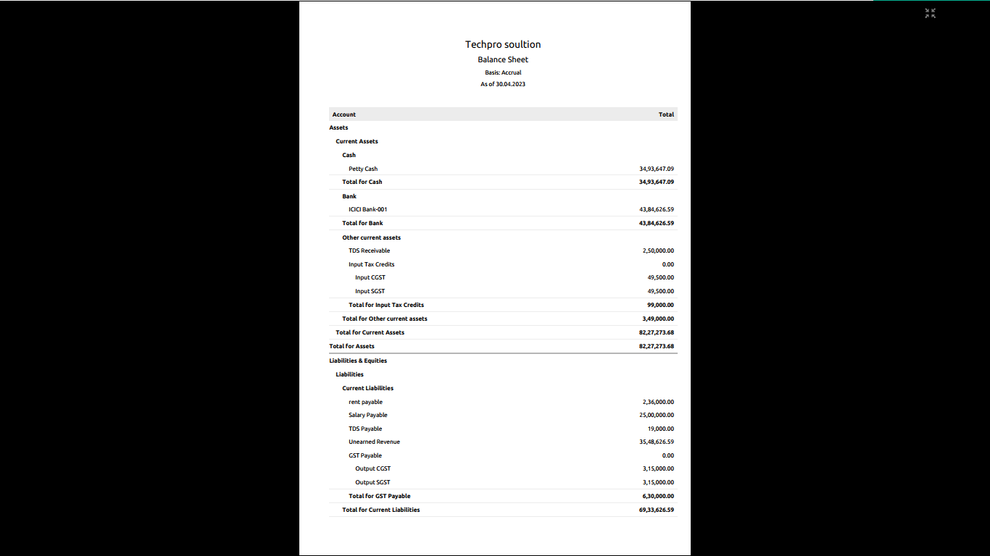

PROFIT AND LOSS(OUTPUT):

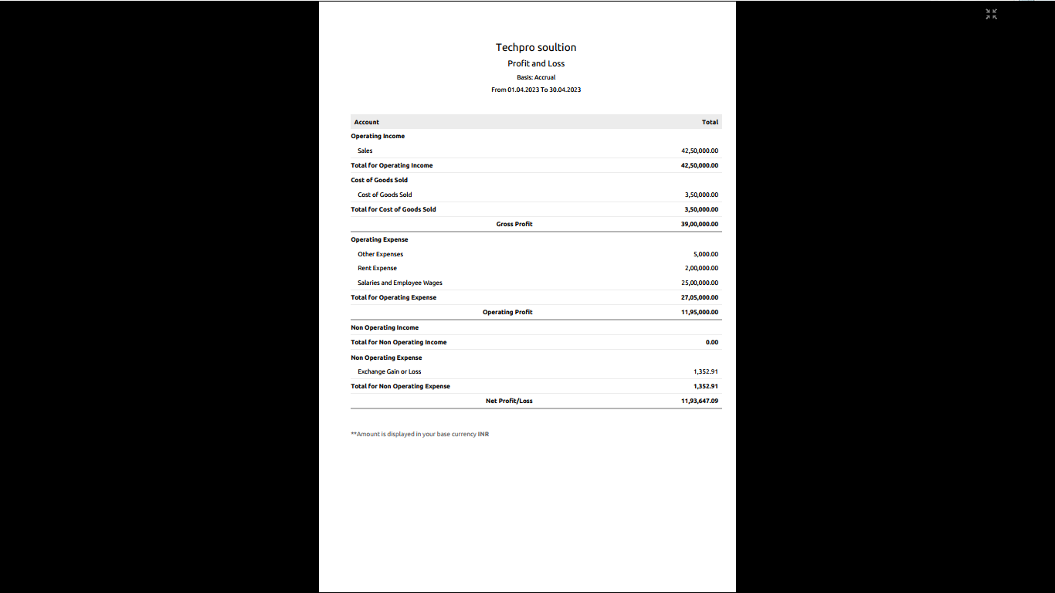

ADVANTAGES AND DISADVANTAGES:

ADVANRAGES:

* + - * We learned about Business Organisation.
      * We learned about Business Transaction.
      * We learned about GST reports and Files.
      * We learned about Tax reports and files(TDS,TCS).
      * We learned about Business Accounting system.

DISADVANTAGES:

* + - * We face more tackles and difficults.
      * We face a lot of mental depression.
      * There was a time barrior at out work.
      * At the beginning of the project, we have no clarity.
      * There is a lot of network issue.

APPLICATION:

We applied through the website **books.zoho.com** for the solution.

CONCLUSION:

We had learned the entire process of the ZOHO books like creating vendors, creating customers, bills, invoice, etc.

FUTURE SCOPE:

* Impacting the types of jobs that will become available.
* As advance system handle repetitive work, humans will deal with more of the analysis, becoming the crucial link between data and clients.

APPEX:

* + - Profit and loss pdf file
    - Balance sheet pdf file
    - Project report
    - Video demonstration of project
    - Screenshot.